March 16, 2020

Dear Jikoen Ohana,
As we continue to monitor the Covid-19 situation and track the information provided by the State Dept. of Health, publich health agencies like the CDC and WHO, Jikoen has decided to take precautions to protect our Ohana. They are our top priority.
We want to let you know that starting March 16 through Thursday, April 30, 2020, Jikoen will suspend temple services, all classes and events.
There will be no temple services at Jikoen for the remainder of March and the month of April.
Sat., April 4 – Annual Jikoen Bazaar is POSTPONED until further notice.
Sun., April 5 – HBC Buddha Day Service will be via YOUTube live streaming. Guest speaker will be Mr. Duane Kurisu, local entrepreneur and philanthropist, Founder and Chair of aio. The streaming URL and further details will be provided at a later date.
Lumbini Preschool will remain open. Under the direction of Rev. Shindo & Mrs. Suzie Nishiyama, it will remain open and they will continue to monitor the Covid-19 situation utilizing the guidance provided by the Federal, State, and local health agencies.
Thank you very much for your support and understanding these past few weeks.

For more information and updates, please go to our website at www.jikoenhongwanji.org
Please feel free to call or email us should you have any questions or concerns. Leave your name and contact number and someone will get back to you as soon as possible.

Sincere gratitude for your trust, loyalty and patience.
Please keep healthy and stay safe.

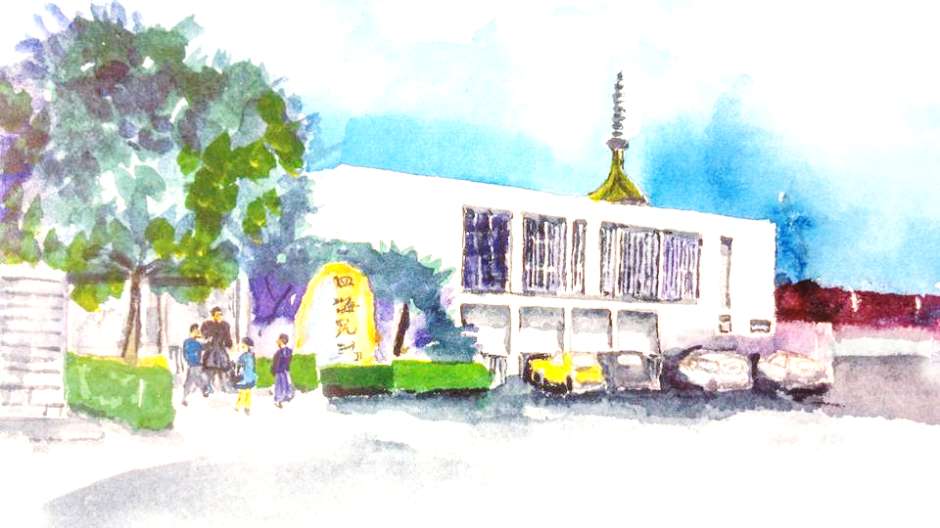
Respectfully in deep gratitude,

Rev. Shindo Nishiyama
Resident Minister

NOTICE OF CLOSURES AND SUSPENSION OF SERVICE
AT JIKOEN HONGWANJI:

- Nokotsudo (Columbarium will be closed)
- Hall Use has also been suspended until further notice
- Ministerial Services - call the office 845-3422 for ...leave name and contact number
- Monthly Newsletter has been suspended
- Calendar - events suspended until April 30
- Affiliate Organizations

