May 1, 2020

Dear Jikoen Ohana,

We hope everyone is doing well during this Covid 19 statewide Shelter-in-Place and Stay-at-Home order.

**Due to the everchanging guidelines, Jikoen has extended suspension of temple services, columbarium (nokotsudo), all classes, meetings, gatherings, and events until May 31.**

There will be no temple services and newsletter until further notice.

Annual Jikoen Bazaar is **POSTPONED** until Oct. 24, (more information to follow).

**July 17-18**  – **Jikoen’s Bon Dance** has been **CANCELLED.**

Under the direction of Rev. Shindo & Mrs. Suzie Nishiyama, **Lumbini Preschool** will remain open and they will continue to monitor the Covid-19 situation utilizing the guidance provided by the Federal, State, and local health agencies.

Thank you very much for your support and understanding these past few weeks.

As Jikoen Sangha, please continue to support each other and keep in contact by sharing information via email, phone, or the postal service.

**We know this is a trying time for everyone. If you are able to help, any financial contribution will be deeply appreciated to help sustain Jikoen during this time.**

Reverend Nishiyama will be available for ministerial emergencies. If you are experiencing an emergency, please call the office or email us should you have any questions or concerns.

Please leave your name, contact number and someone will get back to you as soon as possible.

For more information, video services and inspirational services, please go to our website at[**www**.jikoenhongwanji.org](http://www.jikoenhongwanji.org) or

www.hongwanjihawaii.com

Updates will be posted as this uncertain situation unfolds.

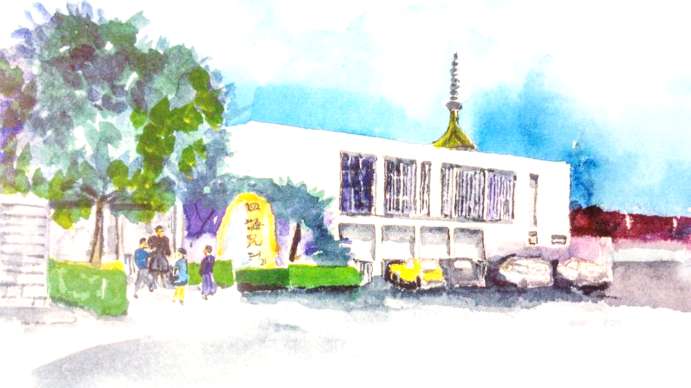Please keep healthy and stay safe. We hope to see you be back at Jikoen soon!

Sincere gratitude for your trust, loyalty, and patience.

Respectfully in Gassho,

Rev. Shindo Nishiyama Doris Oshiro

Resident Minister President (808) 271-4748